STM Studio Supplies
by Professionals for Professionals

Chatswood Business Park 11L /175 Lower Gibbes St Chatswood NSW 2067 T: 02 9417 3000 F: 02 9417 3111
E: sales@stmstudiosupplies.com www.stmstudiosupplies.com

STM Theatre Operations
Risk Assessment Template

Risk management is a proactive process that helps you respond to change and facilitate continuous improvement in your theatre. It should be planned, systematic and cover all reasonably foreseeable hazards and associated risks.
A risk assessment involves considering what could happen if someone is exposed to a hazard. A risk assessment can help you to determine:
- severity of the risk
- whether any existing control measures are effective
- what action you should take to control the risk, and
- how urgently the action needs to be taken

A risk assessment will assist to:
- identify which workers are at risk of exposure
- determine what sources and processes are causing the risk
- identify if and what kind of control measures should be implemented, and
- check the effectiveness of existing control measures

A risk assessment can be undertaken with varying degrees of detail depending on the type of hazard and the information, data and resources that you have available. It can be as simple as a discussion with your workers or involve specific risk analysis tools and techniques developed for specific risks or recommended by safety professionals.

Steps in risk management
- Identify Hazards
- Assess Hazards
- Eliminate hazards
- If unable to eliminate, then control hazards
- Residual risk reassessment

Ensure that:
- Policies are established, promoted and reviewed
- Workers Compensation and other insurances are current and sufficient
- Information, qualifications, experience, and supervision is assessed and addressed
- Systems in place to identify and address training needs
- Maintenance systems to address scheduling, compliance, and monitoring
- Sufficient time and budget allocated to WHS
Risk Ranking Matrix
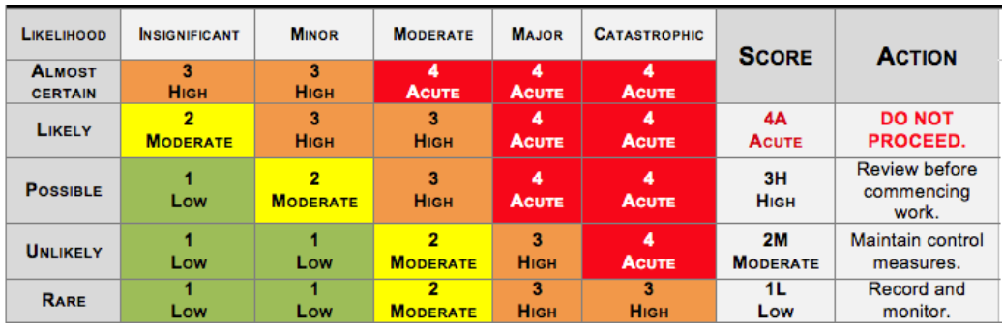

Risk Assessment Control Plan

Person responsible for Risk Assessment: |  |  |  |  | Issue date:
Item | Job Step  List the work tasks in a logical order |  | Potential Hazards & Risk Ranking  Identify the hazards and risks that may cause harm to workers or the public. | Controls & Mitigated Risk Ranking  Describe what will be done to control the risk. What will you do to make the activity as safe as possible?
Example | Enter theatre |  | Tripping or fall 2M | Ensure area is clear and well lit 1L
1

2

3

4

5

6

7

8

9

Part A Safety Inspection of Physical Elements
Delete any that do not apply
Electrics
 |  | Yes | No | Notes
House Lighting is adequate
Aisle Lighting is adequate
Exit lights are in working order
Exit lights are visible from auditorium & stage
Leads are secured and do not cross walkways, aisles or exits
Each fixture has a safety chain
IEC cables/ supply cables not resting on or in heat path of fixtures
Rooms are neat and tidy
Accessories are correctly attached to fixtures
100% of rig checked for safety
Set electrics & practicals tagged & tested
Sound Communication & AV
Leads are secured & do not cross walkways, aisles, or exits
Flown speakers & instruments are correctly. & safely rigged
Flown speakers & instruments have safety chains / 2 rigged points
Looms are neat & tidy
Accessories are correctly attached to fixtures
100% of rig checked tar safety
Noise levels comply with safety guidelines
Comms in auditorium
Scenery & Rigging
Flats a re correctly rigged & braced
Braces are secure & marked
Appropriate use of hardware
All shackles are moused
Winch handles turned around if not in use
Trip hazards are marked
Rosta adequately secured together
Flats & furniture flame retarded
Access
Treads secured
Treads appropriate, rise, overhang, depth
Safety rails erected where required
Rosta & ramp edges are defined
Fly Rail
Lines appropriately weighted & weights strapped in
Floors clear & tidy
Adequate lighting
Trip hazards removed
Loading Galleries & Grids
Counterweights stacked safely & load evenly distributed
Floors clear & tidy
Adequate lighting
Trip hazards removed
Fire equipment accessible
First Aid equipment accessible
Information Tool box
Adequate forms
All tools present
Code of Practice available
Chart of knots present
Part B Safety Inspection of Introduced Elements
Delete any that do not apply, add any that are required
Auditorium
Seating clear & tidy
Exits clean & clear
Aisles clean & clear
Crossovers clean & clear
Stage & Wings
Emergency exits clean & clear
Wings clear & tidy
Corridors & crossovers clean & clear
Stage entrances & exits clear & tidy
Stage entrances & exits appropriately lit
Stage entrances & exits marked
Stage floor swept/vacuumed
Railings safe
Tread, ramp & rostra edges defined, as appropriate
Carpet runners & cable ramps trip safe
Adequate onstage work lights
Adequate blue light in wings
Food areas clean& comply with the Food Act
Waste bins provided
Dressing rooms adequately lit, furnished & ventilated
Emergency Equipment
Easily identified signage present
Fire extinguishers present & unobstructed
Fire hoses present & unobstructed
First Aid kits present & contents complete
Ice packs available
Evacuation procedures posted
Properties
Breakaway items suitable
Safety Data Sheets, SDS, available if required
Risk Assessment attached
Electrical work is safe
Costumes
Risk Assessment attached
Scenery
Risk Assessment attached
Electrical work is safe
Naked Flames on stage
Sand buckets in wings
Suitable methods of extinguishing candles etc
Suitable holders/ drip trays for candles etc
Storage for Dangerous Goods arranged
Sets & props fire retarded
Costumes fire retarded
Additional safety equipment standing by
Risk Assessment attached
Special Effects
Risk Assessment attached
Safety Data Sheets, SDS, available if required
Additional Items
Complete list of Attachments
# | Title |  | Completed by

Source, Safe Work Australia https://www.safeworkaustralia.gov.au/

